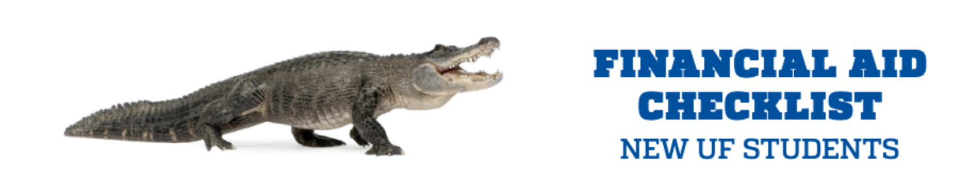

- COMPLETE THE FAFSA
If you would like to be considered for all available financial aid programs, you will need to complete a Free Application for Federal Student Aid (FAFSA) at studentaid.gov, https://studentaid.gov/h/apply-for-aid/fafsa
- To receive the best financial aid offer, you must complete the FAFSA as early as possible. Although you must be accepted for enrollment at UF before you are considered for financial aid, you should apply for aid before being admitted.
- UF’s Federal School Code is 001535
- The FAFSA opens on October 1st each year.

- AFTER COMPLETING THE FAFSA
- After submitting your FAFSA, please email your financial aid advisor at pharmacysfa@cop.ufl.edu to request your financial aid package. Title > FAFSA Update
- Please notice that our office will automatically award your financial aid package if a student enrolls after the financial aid package award period.

- CHECK ONE.UF
Students can access information about their financial aid at https://one.uf.edu/. Log in with your gatorlink username and password.

- View your financial aid awards and summary, https://www.youtube.com/watch?v=oibAZw55HsQ
- Check “To-Dos” and “Holds” to see if you are missing requirements or documentation that could prevent the disbursement of your financial aid.
If your FAFSA application is selected for federal verification, you will be required to provide verifying documentation before aid can be disbursed to you. Respond promptly to requests for information or documentation. Do not wait until school begins to submit required documents. Ask questions if you are unsure about any part of the verification process.
- Complete Entrance Counseling and Master Promissory Note (Graduate/Professional) at studentaid.gov. If applying for a Graduate PLUS loan, must also complete Master Promissory Note for Grad PLUS.
- At ONE.UF, students can monitor financial aid disbursements/refunds, view campus finances, tuition statements payment history and MORE!

- ENROLL IN DIRECT DEPOSIT
Direct Deposit is the quickest and safest way to receive your financial aid refunds. To sign up, go to ONE.UF at https://one.uf.edu/campusfinances/directdeposit and sign in with your gatorlink username and password. Follow the instructions on the screen.

FINANCIAL AID ADVISOR CONTACT INFORMATION
Karina Woodward
Coordinator III - College of Pharmacy
Ph: (352) 273-6202
pharmacysfa@cop.ufl.edu
Appointments via phone or Zoom.

